#What is engineering economy? Why it is important to study engineering economy?
=> Engineering economy is a field of study that focuses on the economic aspects of engineering projects and decisions.
It involves the application of economic principal and techniques to evaluate the costs and benefits of engineering alternatives, ensuring that resources are used efficiently to achieve desired outcomes.

Key aspects:
- Cost Analysis: Evaluating the costs associated with different engineering options.
- Benefit Analysis: Assessing the benefits or return from engineering projects.
- Cost-Benefit Analysis: Comparing costs and benefits to make informed decisions.
- Financial Decision-making: Using economic criteria to guide engineering choices.

Importance of studying Engineering Economy:
- Informed Decision-making: Helps engineers to make informed decisions by considering the economic implication of their choices.
- Resources optimization: Ensure that resources are used efficiently and effectively.
- Cost management: Helps manage and control costs throughout the project lifecycle.
- Risk Assessment: Helps in identifying and mitigating financial risks associated with engineering projects.
- Long term planning: Supports long-term strategic planning and investment.

#Differences between Simple and Compound Interest?
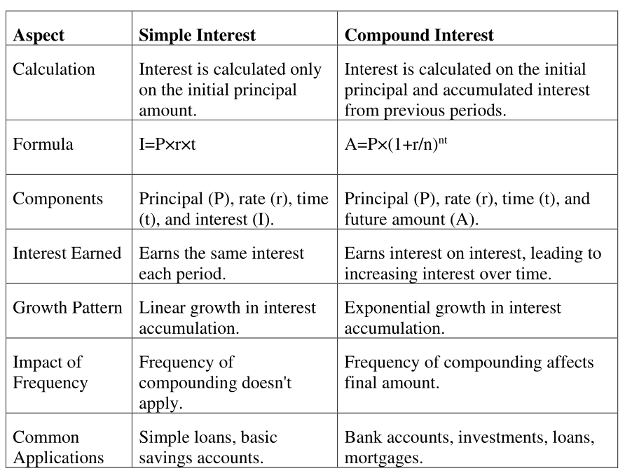

#Distinguish between present value and future value with an example.
Present value: Present value represent the value of money at time zero.
Formula: PV = FV / (1 + r )^{n}
Future value: Future value represent the future sum of money including principal plus interest.
Formula: FV = PV * (1 + r)^{n}

Example: Suppose you have $1000 today (PV) and you want to know how much it will be worth in 5 years (FV) if you invest it at an annual interest rate of 5%

Example: If you expected to receive $1276.28 in 5 years and want to know its present value at 5 % discount rate.

#Define Net Present Value (NPV) and Internal Rate of Return (IRR)
NPV: Net present value is the difference between the present value of cash inflows and the present value of cash outflows over a period of time.

